  Fabio Analysis :

1. Fabio a fast , modern , Zero-configuration Load balancing HTTP(s) router for deploying microservice managed by consul.
2. Fabio is a stateless Load Balancer.
3. Fabio used Random distribution for handling load by default but we can update in configuration for managed load in Round Robin .
4. Every service change automatically reconfigures Fabio without restart and without noticeable latency.
5. Written in Go and deployed as a static binary which can be run without any configuration.
6. Fabio extract information from consul related to service  and update routing table dynamically

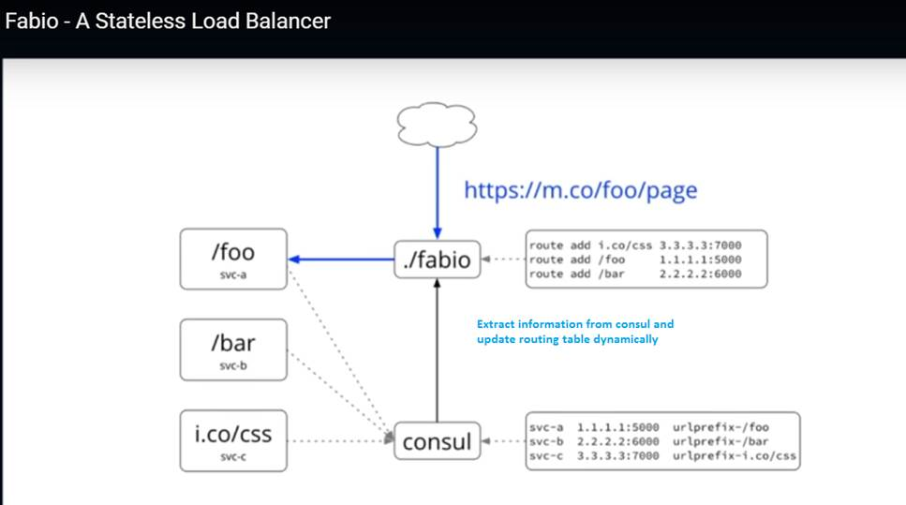

1. Fabio have different check for registering service like only those service will registered they have GREEN health.
2. For running Fabio , prerequite is consul agent should running on your local box.
3. Fabio detect consul configuration changes and update routing table based on that
4. Fabio itself have user Interface for Routing table  (<http://localhost:9998/routes>)
5. There is a manual overrides in case of fix broken deployment  (in case of add / edit/ delete routes)
6. Fabio provide support of Dynamic Traffic shaping   (like  if we want to apply certain percentage should allowed on service A or date we can achieve this )
7. Fabio current version is 1.3.5
8. Fabio only have 4000 Line of code
9. Fabio in Production from since sep 2015.